**Sheriff Control Room Software – Technical Information**

Incoming SMSes will appear under client responses.

SMSes sent to the **client items** window will move to **client responses** if a return SMS is received – this will then show which systems does not respond.

The list can be scheduled to clear automatically and also to send out SMSes/check automatically to see which units does not respond.

The bulk SMS gateway can also be used to send and receive SMSes, but internet is required then, otherwise the GSM modem terminal connected to the PC is used – This also acts as a Dongle and must be used regardless if only Bulk SMS is used.

A copy can be downloaded to check out at

<http://www.smsalert.co.za/Downloads/Sheriff-SMS%20Alert%20Setup%202.4.1.0.exe>

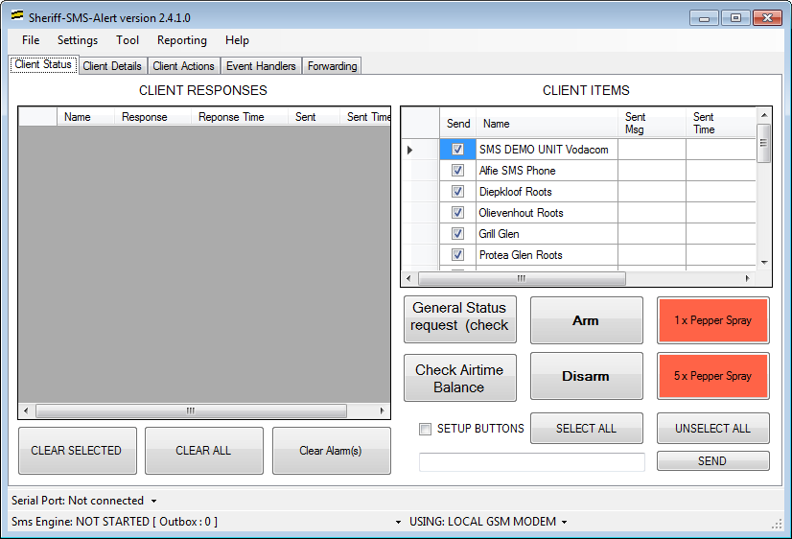

Buttons can be customised, shown text is just an example e.g. armed disarmed etc.

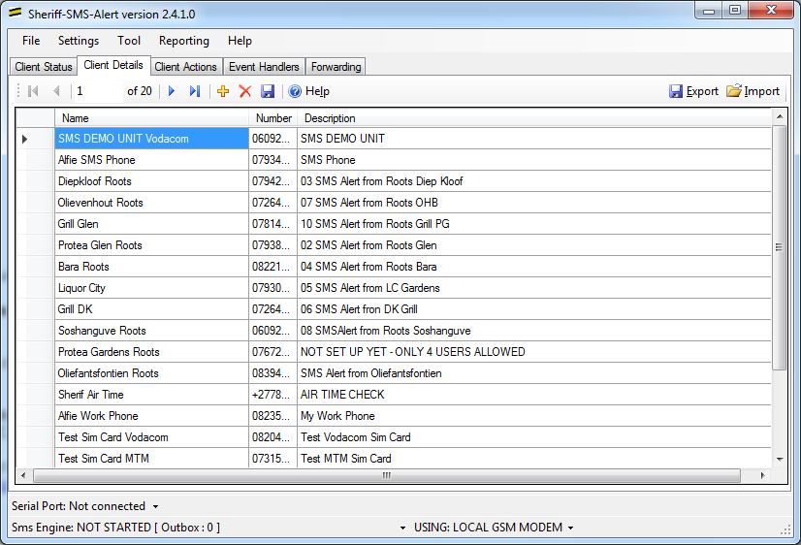

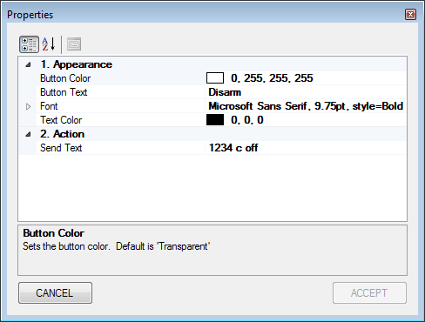

To change the button settings

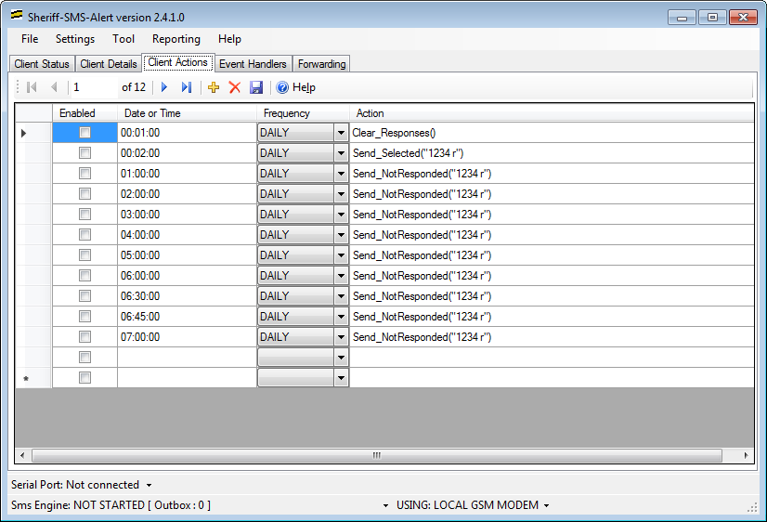

Advance purposes

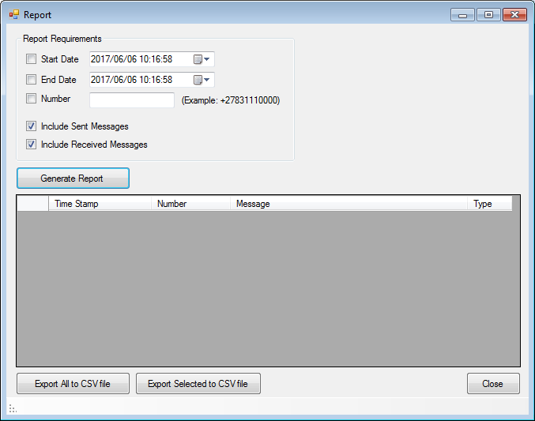

Reporting

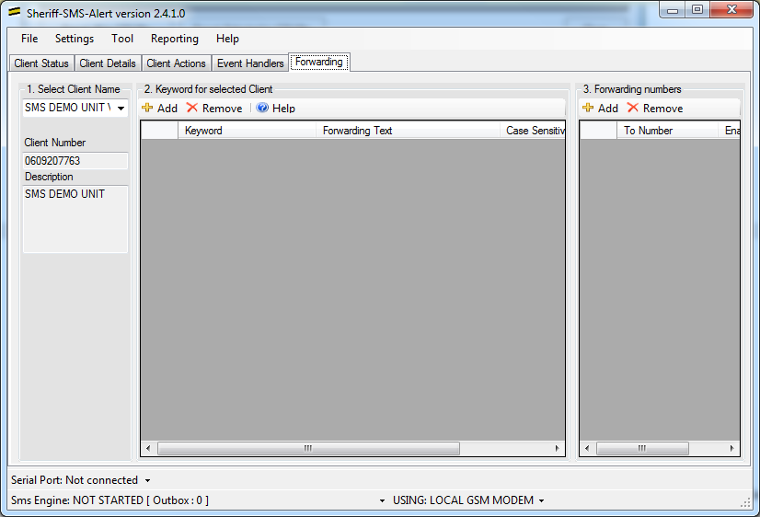

Forwarding, not yet fully tested.



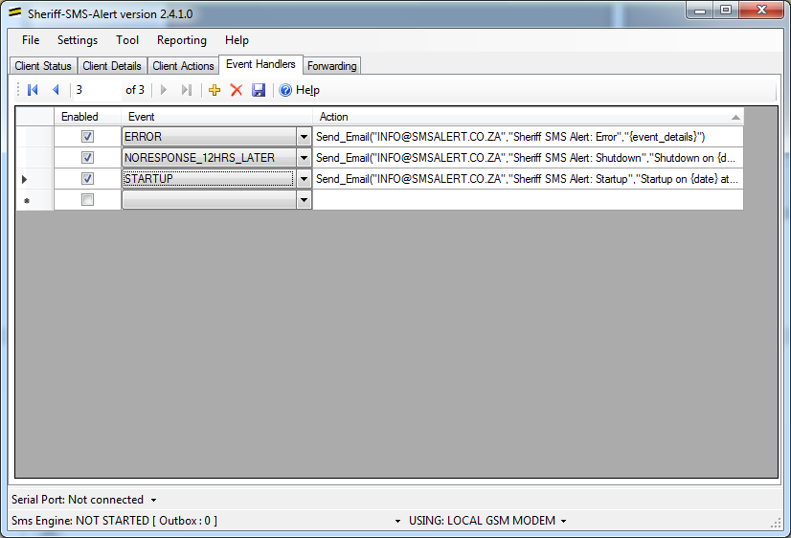



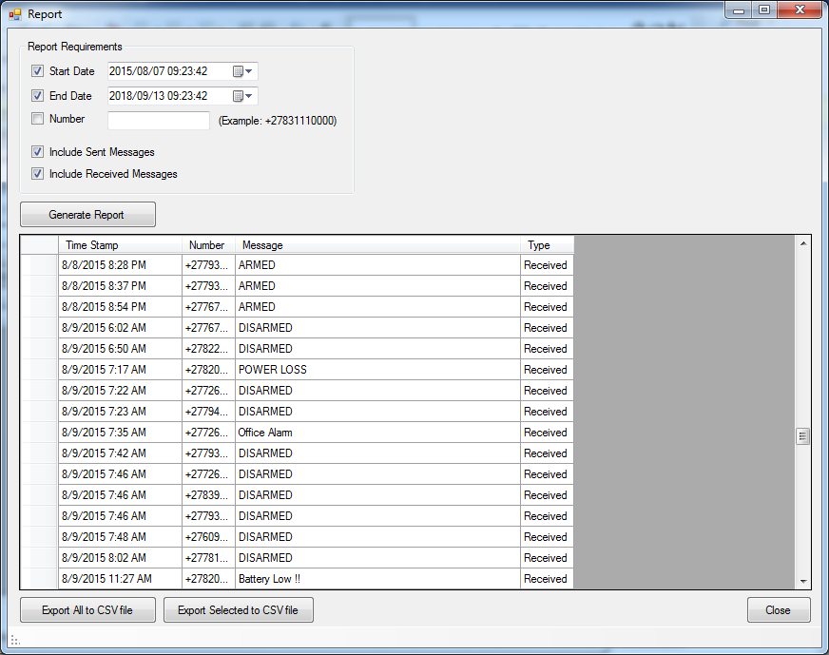

**Actions**

The actions are commands that are used in the '**Action**' column of the "**Scheduled Actions**" and "**Event Handlers**" tabs.  Most commands

**List of actions:**

**Send_All("<text>")**  
The Send_All command will send the <text> to all clients in the database, regardless if a previous response was received or whether their 'Send SMS' box is checked.  
Example: Send_All("1235 r")

**Send_Selected("<text>")**  
The Send_Selected command will send the <text> to all clients in the database, that have their 'Send SMS' option enabled, regardless if a previous response was recevied.  
Example: Send_Selected("1235 r")

**Send_NotResponded("<text>")**  
The Send_NotResponded command will send the <text> to all clients in the database, that have their 'Send SMS' option enabled and have not recevied any reponses.  
Example: Send_NotResponded("1235 r")

**Clear_Responses()**  
The Clear_Reponses command will the clear the reponses for all clients in the database.  
Example: Clear_Reponses()

**Send_SMS("<mobile_number>","<text>")**  
The Send_SMS command will send a SMS to the mobile number, with the <text> message.  
Example: Send_SMS("0831112222","This is a test message")

**Send_Email("<email_address>","<subject>","<message>")**  
The Send_Email command will send an email to the destination <email_address> with <subject> as the email subject, and <message> used as the email body.  
Example: Send_Email("[name@myemail.com](mailto:name@myemail.com)","SMS Alert Event","Hello, this email is from the SMS Alert Program")

**Popup("<text>")**  
The Popup command will display a simple popup message with <text> as content  
Example: Popup("Hello World")

**Text Substitution**

The following text substitutions will be made in the in any of the <text>, <subject> or <message> fields used in the above commands.  When a {Parameter} expression is found in the text, it will be replaced with the value of the parameter. (They are case sensitive)

{time}

{day}

{date}

{event_details}

**System Events**

**STARTUP** : Triggered at the startup of the program  
{event_details}: reports wheter the key.txt file has been found ("key.txt file found" or "key.txt file NOT found")

**SHUTDOWN** : Triggered at the startup of the program  
{event_details}: none

**ERROR** : Triggered when en error occurs with the modem or other selected program errors  
{event_details}: <Details of error>

**NOREPONSE_1HR_LATER** : Triggered when no reponses has been received for one or more clients 1 hour after a message has been sent to those clients.  
{event_details}:  The details for this event is a list of client that has not reponded for this time period; Example: ClientName1, ClientName2, ...

**NOREPONSE_2HRS_LATER** : Triggered when no reponses has been received for one or more clients 1 hour after a message has been sent to those clients.  
{event_details}:  The details for this event is a list of client that has not reponded for this time period; Example: ClientName1, ClientName2, ...

...

**NOREPONSE_24HRS_LATER** : Triggered when no reponses has been received for one or more clients 24 hours after a message has been sent to those clients.  
{